
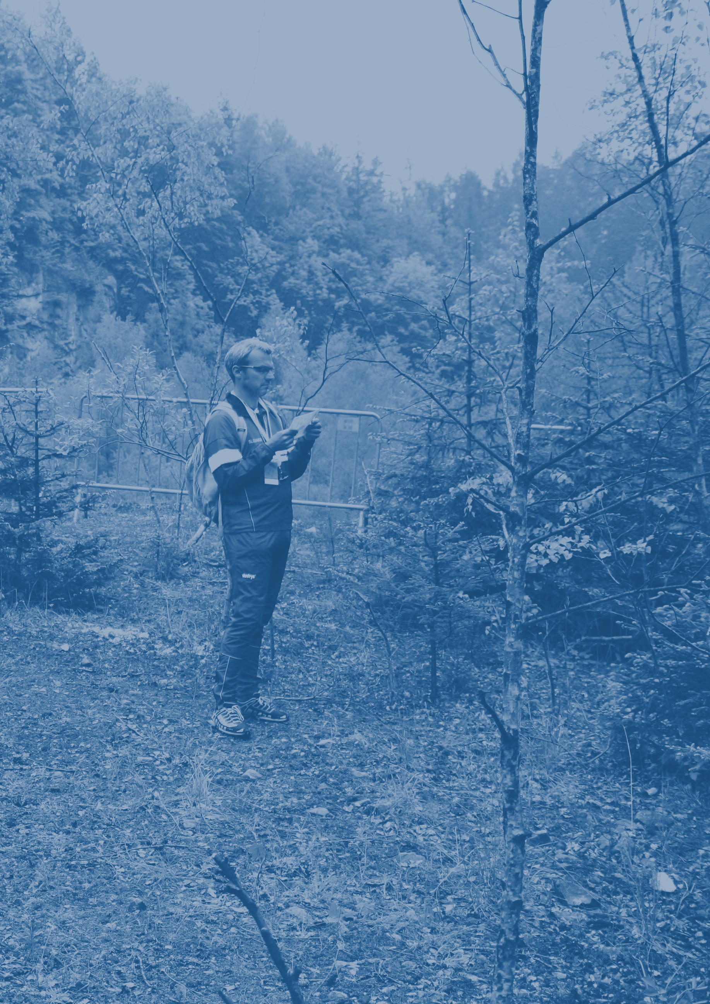
November 2016
BULLETIN 1
WWW.ETOC2018.SK
Contents

WELCOME BY THE EVENT DIRECTOR 3
VENUE 4
ORGANISING TEAM 5
COMPETITION RULES 5
EVENT PROGRAMME 6
TRAINING POSSIBILITIES 6
EMBARGOED AREAS 7
TERRAINS AND PREVIOUS MAPS 8

info@etoc2018.sk
www.etoc2018.sk
www.facebook.com/etoc2018
+421 908 226 250
Welcome by the event director
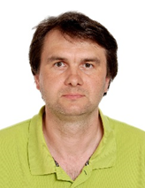
Dear orienteering friends,
I would like invite all competitors, officials and guests on behalf of the organizing committee and orienteering club Slávia Farmaceut Bratislava to the European Trail Orienteering Championships 2018 in Slovakia.
The Slovak orienteering association has great experiences with organizing some important events in past like Junior World Orienteering Championships 2012 in Kosice, World University Orienteering Championships 2006 in Kosice, Orienteering World Cup in years 1988 (Silická planina) and 1998 (Tatranská Lomnica), European Youth Orienteering Championships 2003 in Pezinok, Junior World Ski Orienteering Championships 2000 in Banská Bystrica, Junior World Ski Orienteering Championships 1996 in Banská Bystrica and World Mountain Bike Orienteering Championships 2005 in Banská Bystrica. The next European Youth Orienteering Championship 2017 will be held in Banská Bystrica. You can meet some people from these events in year 2018 too.
Trail Orienteering is relatively new discipline in Slovakia but has quickly acquired importance like other orienteering disciplines. The first competition on Slovak territory took place during the Slovak championships in Sprint (organized by our club) on 13 September 2008 and it was prepared by the Hungarian federation. We had to wait a long time for the next TrailO competition. The first competition organized by Slovak club on Slovak territory was a local competition with 47 participants organized by our club on 25 January 2014. We started very close cooperation with the Czech federation and our skills and experience widely grew. The club TJ Slávia Farmaceut Bratislava has organized 9 national TrailO competitions (7 with international participants) and two ECTO competitions in Slovakia during last three years. We organized three TrailO competitions in the Czech Republic last year too.
Our goal is to prepare fair and nice competition with the possibility to explore beauty and interesting places in Slovakia. I would like to apologize that you may face a little bit higher requirements for traveling, but each competition will be held in different type of terrain with great demands on TrailO skills. You will meet flat, hilly and steep slopes, different vegetation mostly in non-urban areas. We will pay special attention to Paralympic competitors by selecting asphalt or another firm surface on majority competitions and paths.
The European Trail Orienteering Championships 2018 will be held in the beautiful capital of Slovakia, a small town named Bratislava, and its neighbourhood. Bratislava is famous for unique architecture, culture, history tradition, art, drinks, food and nightlife.
I wish all of you a lot of success and good preparations for our event in year 2018. I assure that we will prepare this event on the highest possible level.

Dušan Furucz
Event Director
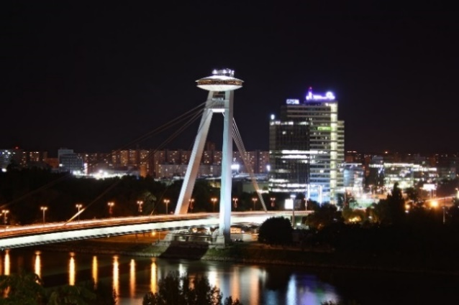
Venue
The European Trail Orienteering Championships 2018 will be held in Bratislava, the capital of Slovakia, and its neighbouring areas - the Záhorie lowlands and the Little Carpathian mountains.
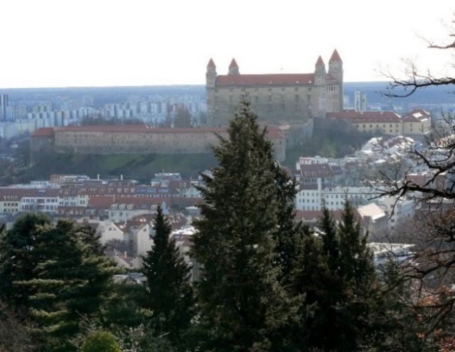
The lowland Záhorie is very flat region in western Slovakia between the Little Carpathians mountains on the east and the river Morava on the west. This area is well known for its sandy dunes covered by pine forest and large training military areas.
The Little Carpathians are a relative low and narrow mountain range with very diverse relief. They are part of the Carpathian Mountains. The mountains begin in Bratislava and continue about 100 km to the north. This territory is largely covered by deciduous forests with beech, common ash, sycamore maple and linden.
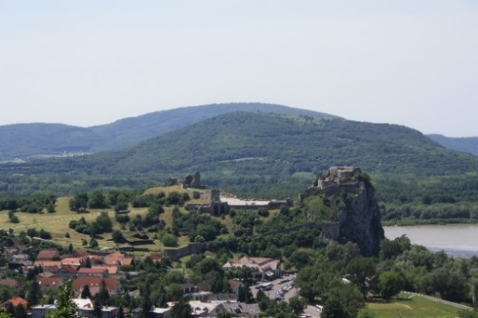
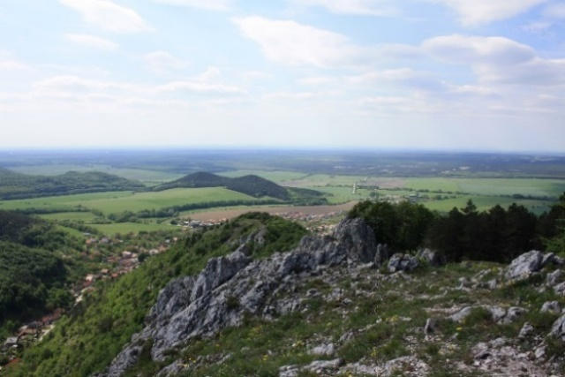
Bratislava is the political, cultural and economic centre of Slovakia with a population of about 450,000 inhabitants and located in the southwestern Slovakia, at the junction of rivers Danube and Morava. Bratislava is very close to two other countries Austria and Hungary. Bratislava is historically tied with these countries and during long history it was a significant economic, cultural and political centre of Central Europe. You can find a lot of unique architecture, culture, history tradition, art, drinks, food and nightlife in this “small” city.
The individual races will be held in different municipalities. Borský Mikuláš, Devín (Bratislava), Plavecký Mikuláš and Stupava are small villages but with very beautiful and diverse nature. You can see the very flat forests change to rugged terrain forms or extremely steep slopes.
http://www.visitbratislava.com
http://www.slovakiatouring.com
Organising team
The event will be organized by members of the orienteering club “TJ Slávia Farmaceut Bratislava”, with the support of the Slovak Orienteering Association. Main officers are:

Dušan FURUCZ Event Director, Mapper
Ján FURUCZ Course Setter
Silvia SHAHZAD Technical consultant for Paralympics
Jakub VALACH Design
Ladislav KASZA IT & Equipment
Petra KOTULIAKOVÁ PR & Media
Zuzana JANOTOVÁ Catering, Protocol, Accommodation and Secretary

Ari TERTSUNEN (FIN) IOF Senior Event Adviser
Marián MIKLUŠ National Controller

Competition rules
The Competition Rules for IOF Trail Orienteering Events (valid from 1 January 2017) and the ETOC Rules (valid from 1 January 2016) shall apply to the European Trail Orienteering Championships 2018. Copy of the Rules is available for download from the Rules section in the official IOF website (www.orienteering.org).

The following deviation of the Competition Rules applies:
There are not deviation according to Competition Rules

Event programme
Date | Event | Location
Thursday, April 26 | Event Office Opens, Arrivals | Bratislava
Friday, April 27 | Model Events  Opening Ceremony | Záhorie  Bratislava
Saturday, April 28 | Relay | Devín
Sunday, April 29 | TempO (Q+F) | Borský Mikuláš
Monday, April 30 | PreO - Day 1 | Stupava
Tuesday, May 1  (National Holiday) | PreO - Day 2  Closing Ceremony & Banquet | Plavecký Mikuláš  Bratislava
Wednesday, May 2 | Departures | Bratislava

Training possibilities
On request, ETOC organizers can provide maps and opportunities for team preparations for the ETOC 2018 on similar or near terrains.
More information about training possibilities will be published on the official ETOC website.

Embargoed areas
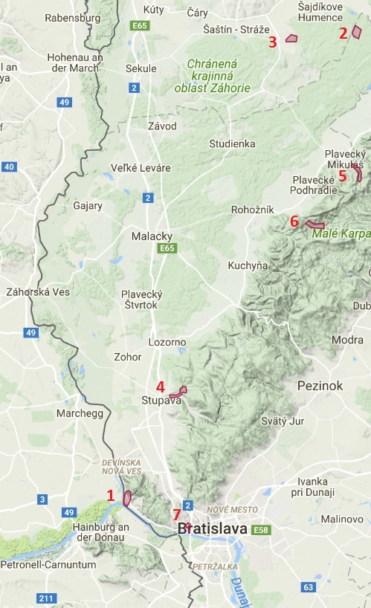
1. Devín
2. Sahara (Záhorie)
3. Borský Mikuláš
4. Stupava
5. Kršlenica (Plavecký Mikuláš)
6. Sološnica
7. Rovnice (Bratislava) - backup terrain

All embargoed areas are out of bounds for all potential ETOC 2018 team members (competitors, officials, escorts, etc.) and any other person who may influence the results of the competitions by any knowledge of the terrain.

You can find more information about embargoed areas in the official website.

Terrains and previous maps
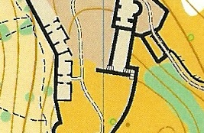
1. Devín (Bratislava) (48.173663, 16.978794)

1:3000, e=5m, 2014, ISSOM
An ancient ruins of castle Devín located on a spectacular rocky cliff with archaeological excavations reminding marked ground plans of buildings, grassy hilly areas. 150 - 200m above sea level.
Last FootO competition in year 2015. Never used for TrailO.

No previous map
2. Sahara (Záhorie) (48.635100, 17.321255)

A flat terrain of military area in lowland Záhorie – pine forest and sand meadows with dunes and artificial objects. 200 - 250m above sea level. Never used for orienteering.

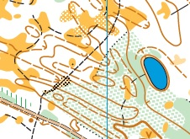
3. Borský Mikuláš (48.628111, 17.223697)

1:4000, e=2m, 2015, ISSOM
A typical flat terrain for lowland Záhorie – pine forest with sand dunes. A forest path with mostly firm surface but on some places with sand surface. 200 - 250m above sea level. Last FootO competition in year 2016. Last TrailO competition in year 2015.

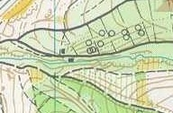
4. Stupava (48.280444, 17.055993)

1:15000, e=5m, 1990, 1:5000, e=5m, 2000, ISOM
A typical Little Carpathians hilly terrain covered by deciduous forests and parks with various vegetation - mostly maintained lawns and deciduous forests. 180 - 280m above sea level.
Last FootO competition in year 1990 (2000). Never used for TrailO.

No previous map
5. Plavecký Mikuláš (48.502577, 17.320693)

A typical karst valley with karst surface and high steep slopes. Territory largely covered by deciduous forests with beech, common ash, sycamore maple and linden. 300 - 500m above sea level.
Never used for orienteering.

No previous map
6. Sološnica (48.448669, 17.250037)

A typical Little Carpathians valley. Territory largely covered by deciduous forests with beech, common ash, sycamore maple and linden. 300 - 500m above sea level.
Never used for orienteering.

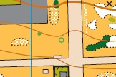
7. Rovnice (Bratislava) (48.148713, 17.072576)

1:4000, e=2,5m, 2014, ISSOM, backup terrain
University campus with various vegetation - mostly maintained lawns and deciduous forests, botanical garden. 130 - 200m above sea level. Last FootO competition in year 2014. Last TrailO competition in year 2014.
Organisers


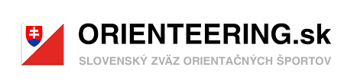


TJ Slávia Farmaceut
ul. Odbojárov 10
832 32 Bratislava
Slovak republic
